MODULE - 1

1. **what is software engineering?**

**Ans.**

**Software** : a program or set of programs containing instruction which provide desired Functionality.

**Enginnering**: process of designing and building something that ensure particular purpose.

**Software engineering**:

- software engineering is the art of devloping quality software on time and within budget.   
software Engineering is a systemetic approch to the design, devlopment, operation, and maintainance of a software system.

In short, software engineering is the discipline of designing, developing, testing, and maintaining software systems. It encompasses various principles, methodologies, and practices to ensure the efficient and reliable creation of high-quality software products.

Software engineering is a branch of engineering that deals with the design, development, testing, maintenance, and management of software systems. It encompasses various principles, methods, tools, and techniques to ensure the efficient and reliable creation of high-quality software products.

1. **Types of Software:**

**Ans.**

1. **System Software**
2. **Application Software**
3. **Programming Software**
4. **Embedded Software**
5. **Enterprise Software**
6. **Educational Software**
7. **Entertainment Software**
8. **System Software:**

Provides a platform for other software to run on. Examples include operating systems (e.g., Windows, macOS, Linux), device drivers, and utility programs (e.g., antivirus software, disk defragmenters).

1. **Application Software:**

Designed to perform specific tasks or functions for end-users. Examples include word processors (e.g., Microsoft Word, Google Docs), spreadsheet programs (e.g., Microsoft Excel, Google Sheets), email clients (e.g., Microsoft Outlook, Gmail), web browsers (e.g., Google Chrome, Mozilla Firefox), and multimedia players (e.g., VLC media player, Windows Media Player).

1. **Programming Software:**

Tools used by software developers to create, debug, and maintain software applications. Examples include integrated development environments (IDEs) like Visual Studio, Eclipse, and JetBrains IntelliJ IDEA, as well as text editors (e.g., Sublime Text, Atom) and version control systems (e.g., Git, SVN).

1. **Embedded Software:**

Software that is embedded within hardware devices and performs specific functions. Examples include firmware in smartphones, tablets, and IoT devices, as well as control software in appliances, automotive systems, and industrial machinery.

1. **Enterprise Software:**

Designed for organizations and businesses to support their internal operations and processes. Examples include enterprise resource planning (ERP) systems, customer relationship management (CRM) software, supply chain management (SCM) software, and human resource management (HRM) software.

1. **Educational Software:**

Designed to facilitate learning and education. Examples include interactive educational games, simulations, learning management systems (LMS), and educational content creation tools.

1. **Entertainment Software:**

Intended for entertainment and leisure activities. Examples include video games (console, PC, mobile), multimedia applications (streaming services, music players), and virtual reality (VR) experiences.

1. **Explain SDLC (Software Devlopment Life Cycle) ?**

SDLC stands for Software Development Life Cycle. It is a process used by software development teams to design, develop, test, and deploy software products. SDLC provides a structured framework for carrying out these activities in a systematic and organized manner. Here's an explanation of the phases typically involved in the SDLC:

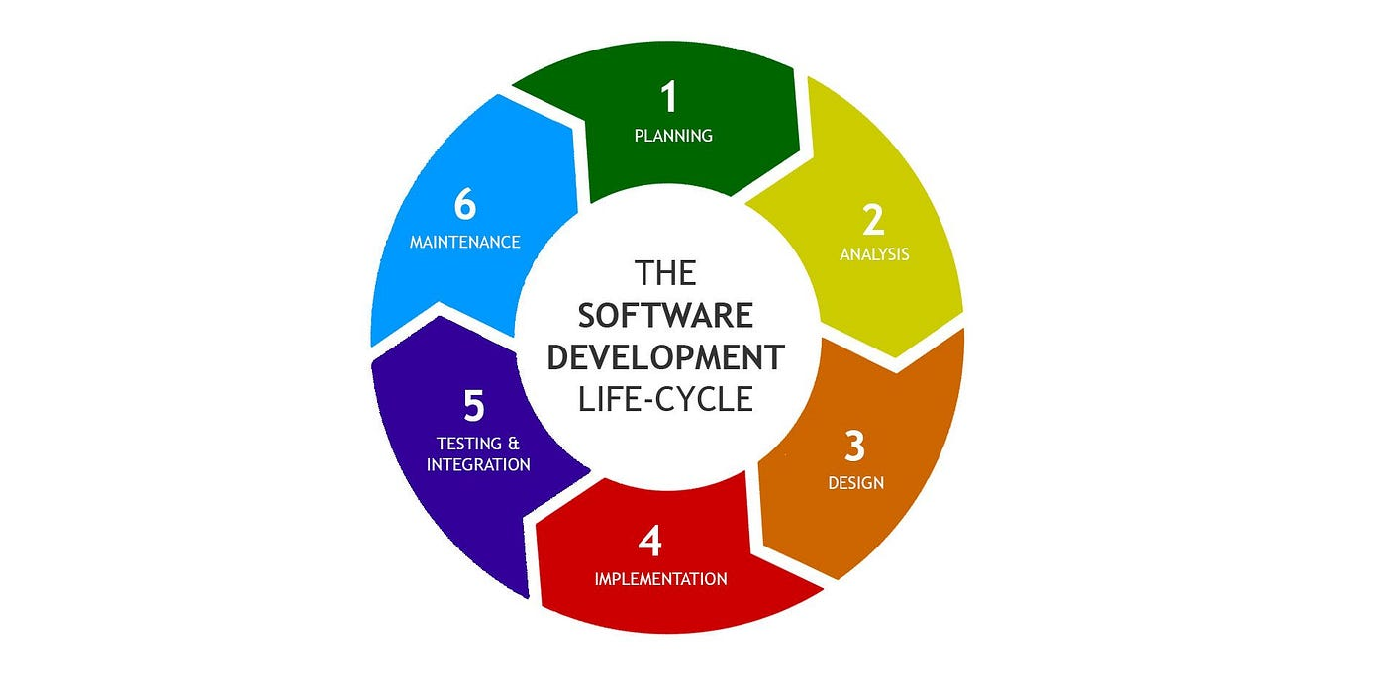

1. **Planning:**

In this phase, the project objectives, scope, requirements, and constraints are identified and documented. Key stakeholders are involved in defining the project vision, goals, and deliverables. Project planning includes creating a project plan, defining roles and responsibilities, estimating resources, and establishing timelines and milestones.

**2.Analysis:**

During the analysis phase, the requirements gathered in the planning phase are analyzed in detail to understand the needs of end-users and stakeholders. This involves identifying functional and non-functional requirements, conducting stakeholder interviews, analyzing business processes, and documenting use cases and user stories.

**3.Design:**

In the design phase, the software architecture and detailed design are developed based on the requirements identified in the analysis phase. This includes defining the overall system architecture, designing the user interface, creating data models and database schemas, and specifying the system components, modules, and interfaces.

**4.Implementation:**

The implementation phase involves coding or programming the software based on the design specifications. Programmers write code using programming languages and development tools, following coding standards and best practices. This phase also includes unit testing to verify the correctness of individual components and modules.

**5.Testing:**

In the testing phase, the software is tested to ensure that it meets the specified requirements and quality standards. Different types of testing, such as unit testing, integration testing, system testing, and acceptance testing, are performed to identify defects and validate the functionality, performance, and usability of the software.

**6.Maintenance:**

The maintenance phase involves managing and supporting the software after it has been deployed. This includes fixing bugs and issues reported by users, implementing enhancements and updates, and addressing changes in the operating environment or user requirements. Maintenance activities aim to ensure the long-term reliability, security, and performance of the software.

**4.What is DFD? Create a DFD diagram on Flipkart?**

**Ans.**

* DFD stands for Data Flow Diagram. It's a graphical representation of the flow of data through a system, illustrating how input data is transformed into output data through various processes.
* In a DFD, data flows are represented by arrows, processes are represented by circles or rectangles, and data stores are represented by open-ended rectangles.
* DFDs are commonly used in software engineering and systems analysis to visualize and understand the structure and behavior of a system. They're especially useful for understanding complex systems and for communicating system requirements to stakeholders.

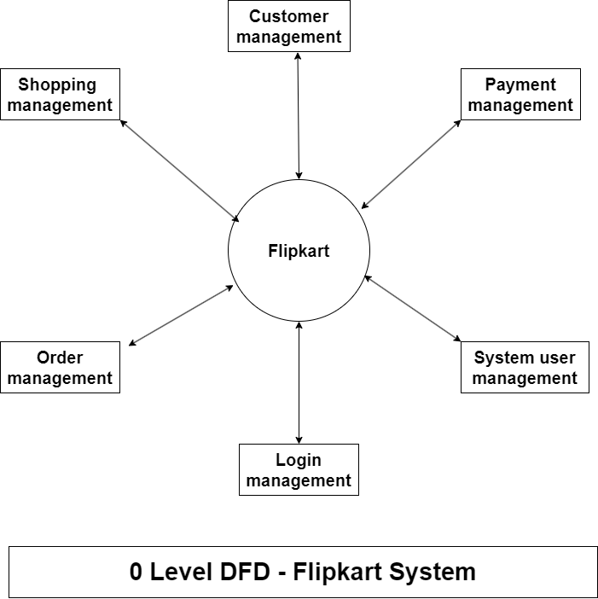

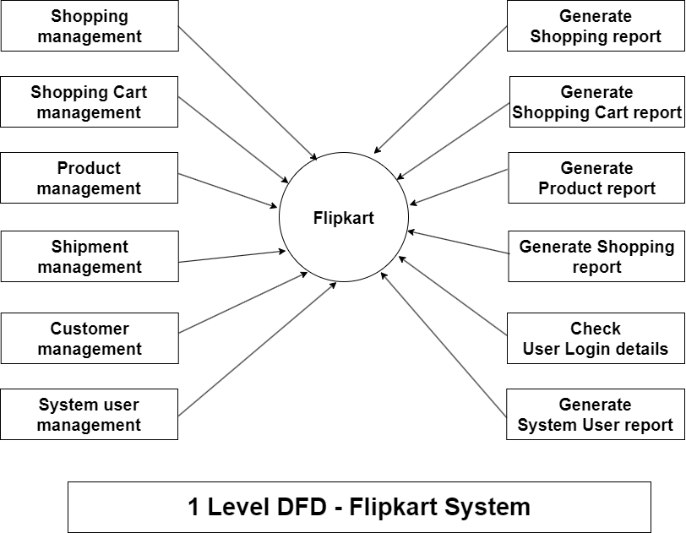

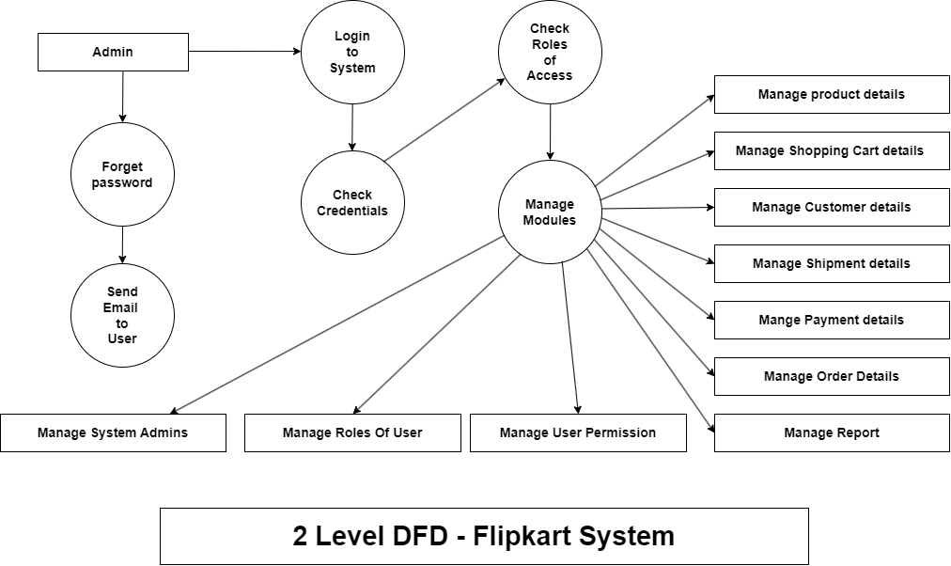

**5. What is Flow chart? Create a flowchart to make addition of two numbers**

**Ans.**

A flowchart is a visual representation of a process or algorithm, using symbols and arrows to illustrate the steps involved and the flow of control from one step to another.

It's a widely used tool in various fields such as software development, business process analysis, project management, and problem-solving.

**Steps Of Alogorithm**:

1] Start

2] Declare variable num1,num2;

3] Get value from user

4] Sum of num1 and num2

5] Display result

6] End

**Flow chart**

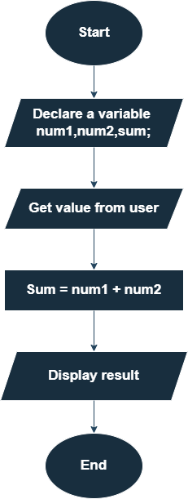

**6. What is Use case of diagram? Create a use-case on bill payment on paytm.**

**Ans.**

Diagrams are visual tools used across industries to represent complex information, aiding in communication, analysis, and planning.

They help in illustrating processes, structures, relationships, and concepts more intuitively, making it easier for stakeholders to understand and work with the information presented.

* Use-case on bill payment on paytm:-

